Assignment 5: Deployment Strategy (Big Data / Hadoop Text Analytics)
Predict 453
Section 55
Spring Quarter

School of Continuing Studies
Northwestern University

Janki Vora & Daniel Prusinski
IT Specialist Data Analyst
IBM US Bank
Dallas/Fort Worth Minneapolis
TX MN

In Compliance with Master of Science Predictive Analytics

Provide an overview (five to eight pages) of how an ongoing process could be setup to regularly access unstructured data sources, extract the relevant information, integrate this information into a predictive model, and export the predictions to a business process such as a website, call center, or other system where decision are made. Leverage data examples from your earlier assignments and focus on the flow of the process and describe how each step is connected to the next.
The paper discusses how BigInsights (IBM's Hadoop Platform) can be used to do Text Analytics on large data sets also referred as BigData. Big Data is defined with 4 V's in the industry viz Volume, Variety, Velocity and Voracity. We will first discuss briefly what BigInsights(or Hadoop) Platform for BigData is. We will then briefly explain the end to end deployment cycle taking use case of Media Industry.
Architectural Diagram of Setting up BigInsights Platform:
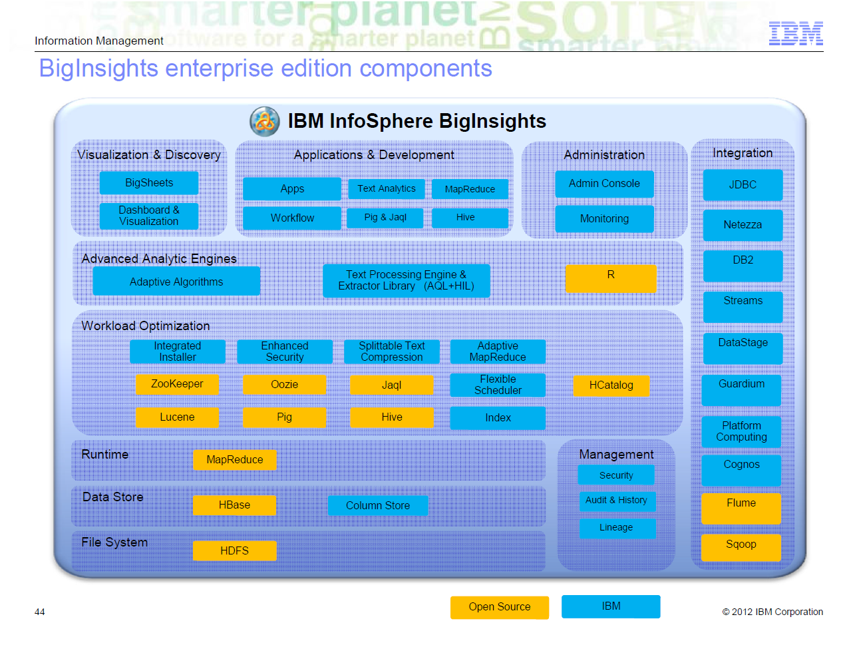
We will now cover some basic concept before discussing the end to end development scenario.
What is Hadoop?
Apache™ Hadoop® is an open source software project that enables the distributed processing of large data sets across clusters of commodity servers. It is designed to scale up from a single server to thousands of machines, with a very high degree of fault tolerance. Rather than relying on high-end hardware, the resiliency of these clusters comes from the software’s ability to detect and handle failures at the application layer.

Apache Hadoop has two main subprojects:
- MapReduce - The framework that understands and assigns work to the nodes in a cluster. MapReduce is the heart of Hadoop®. It is this programming paradigm that allows for massive scalability across hundreds or thousands of servers in a Hadoop cluster.
- HDFS - A file system that spans all the nodes in a Hadoop cluster for data storage. It links together the file systems on many local nodes to make them into one big file system. HDFS assumes nodes will fail, so it achieves reliability by replicating data across multiple nodes. Data in a Hadoop cluster is broken down into smaller pieces (called blocks) and distributed throughout the cluster. In this way, the map and reduce functions can be executed on smaller subsets of your larger data sets, and this provides the scalability that is needed for big data processing.
Hadoop is supplemented by an ecosystem of Apache projects, such as Pig, Hive and Zookeeper, that extend the value of Hadoop and improves its usability.
Hadoop changes the economics and the dynamics of large scale computing. Its impact can be boiled down to four salient characteristics.
Hadoop enables a computing solution that is:
- Scalable– New nodes can be added as needed, and added without needing to change data formats, how data is loaded, how jobs are written, or the applications on top.
- Cost effective– Hadoop brings massively parallel computing to commodity servers. The result is a sizeable decrease in the cost per terabyte of storage, which in turn makes it affordable to model all your data.
- Flexible– Hadoop is schema-less, and can absorb any type of data, structured or not, from any number of sources. Data from multiple sources can be joined and aggregated in arbitrary ways enabling deeper analyses than any one system can provide.
- Fault tolerant– When you lose a node, the system redirects work to another location of the data and continues processing without missing a beat.
The below is the architectural and end to end scenario description of using Text Analytics on Hadoop Platform. The use case is to use Big Data for Media and Entertainment industry.


Streams Ingest
Ingest
BigInsights HDFS Cluster
Text Analytics
Social Media Extractors
Reports
User Queries
BigSheets
AQL
Campaign
Management
Systems
Business
Intelligence
Systems
Social Media Profiles
Predictive Text Models
Real Time Analytics
Streams

BigInsights is being used ad effectiveness, monitoring, and placement sales at many Media companies. BigInsights has pre-built extractors that can be offered through an engagement with the Text Analytics product built into the platform. Ingest from Boardreader (forums, blogs) and GNIP (Twitter, Facebook, other) are already tested and available. Direct ingest is also in production at our customers. As data enters the BigInsights Cluster, Text Analytics looks for patterns relevant to the customer. In a very short time (a few weeks), BigInsights is finding results that are directly useable to marketing and sales analysts, campaign management systems, and to business intelligence systems. Furthermore, the social media models can not only measure the effectiveness of ads, but measure it by categories: by geography, by micro-segmentation (name, gender, age, location), but can help understand WHY the scores are what they are.
Usually the first task of a project is to
Step 1: Load data into a cluster
  - The data can be loaded initially by bulk loading
  - Some usecases may require data to continuously load during production. For instance data updating on the web, twitter etc need to be stored on hadoop.
Below we will discuss two patterns of data ingestion. Ingesting data at rest and ingesting data in motion.
[1]Ingestion Solution for Data at Rest
The command hadoop fs can be used to transfer between local file system and HDFS
hadoop fs -put <local file> <hdfs file>
hadoop fs -get <hdfs file> <local file>
The command hadoop distcp transfers between HDFS
hadoop distcp <hdfs file> <hdfs file>
[2]Ingestion Solution for Data in Motion
- Flume: A distributed service for collecting data and persisting it in a centralized store
  - Can be use to collect data from source and transfer it to HDFS
  - Can be configure to tail a single file or a directory of files
  - Can do parallel transfer
  - Flume agents are placed in source location
  - Flume master configures the collection of data

Step 2: ETL (Extraction, Transformation and Load) process (optional, but necessary)
  - Data cleansing/transformation
  - Binary data is significantly faster to process
  - Typed data is significantly faster to process
  - Compressed data saves disk space
Step 3: Text Analytics:
The unstructured data is analyzed using Text Analytics accelerator, R or other Map Reduce programming that is run on top of the data ingested and stored on HDFS.
Step 4: Results of Text Analytics and Visualizations.
The output of the Text Analytics could be sentiment, event triggers etc. This is outputed to reports. There are several products like BigSheets, Data Explorer etc. that can be used to visualize such large data sets. Applications are written to utilize this data. In the above scenario we se the output results can be visualized as reports or can be used as inputs to create Micro segments which can further be used to
Step 5: Production System also need to take care of Security & Reliability (failure recovery). Also there is governance required to be build to rescore the model from time to time.

